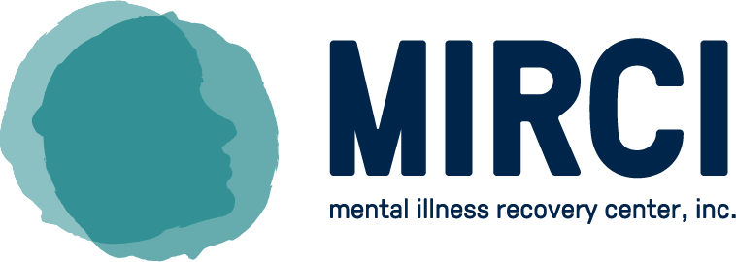

**MIRCI**

MIRCI – Mental Illness Recovery Center Inc., is a full service behavioral healthcare organization that has been serving the community’s most vulnerable population, individuals who are homeless and recovering from mental illness, for over 60 years. MIRCI’s mission is to create pathways to recovery for individuals who are experiencing or at risk of mental illness and/or homelessness. In order to accomplish its mission, MIRCI provides the following services to help people live as independently as possible:

* Homeless Outreach and Benefits Assistance: ensuring the clients we engage have access to income, food, and healthcare
* Permanent Supportive Housing: providing safe and stable homes to individuals and families who were formerly homeless
* Behavioral Healthcare screening: evaluating mental status of individuals who may be experiencing mental illness
* Assertive Community Treatment (ACT) services, an evidence based best practice providing life-long behavioral healthcare to those who have been diagnosed with a severe and persistent mental illness.

**Youth Services**

MIRCI provides services to youth, young adults age 17-24, through its Youth Drop-in Center (YDC) and transitional living program. The YDC provides access to basic needs, behavioral healthcare, and referral to community partners for housing, medical, legal, education, and employment resources. The services are offered 365 days a year, and operates Monday- Friday 8:30 a.m.-5:00 p.m., and Saturday and Sunday Noon – 6:00 p.m.

|  |  |
| --- | --- |
|  |  |

**COVID-19**

MIRCI noticed a 20% increase in since the onset of the pandemic and responded to the needs of the community by opening an adult outreach center. The facility serves as a place where individuals without shelter can meet with doctors for screenings, receive help completing benefit applications, and housing assistance. The services are offered 365 days a year, and operates Monday- Friday 8:30 a.m.-5:00 p.m., and Saturday and Sunday Noon – 6:00 p.m.

|  |  |
| --- | --- |
|  |  |

**Outcomes:**

**Housing**

MIRCI provides permanent supportive housing to adults, unaccompanied youth, and families with children through the Supportive Housing and HomeBase Programs.

In 2020, 94 individuals were served in the Supportive Housing Program. The HomeBase Program served 182 adults, 27 children, and 16 youth.

The Transitional Living Program served 21 youth.



**Behavioral Healthcare**

MIRCI connects adults and unaccompanied youth with access to behavioral healthcare, shelter, and community resources through the Homeless Outreach Program. In 2020, the program served 325 individuals.

MIRCI provides psychiatric care, medication management, ongoing therapeutic interventions, and trauma-sensitive treatment to adults through Behavioral Healthcare, Psychiatrists, and Assertive Community Treatment (ACT) Teams. These programs served 273 adults and 27 youth in 2020.

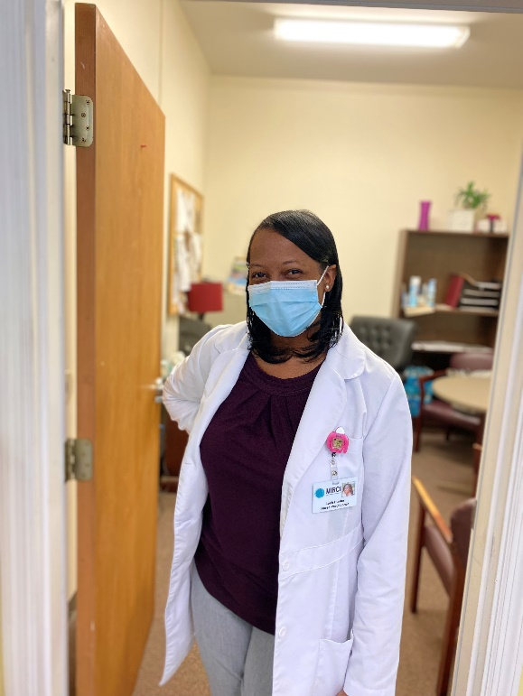

**Benefits Assistance**

MIRCI helps adults and unaccompanied youth apply for and obtain disability and other mainstream benefits through the Benefits Assistance Program. In 2020, the program helped 261 individuals complete applications.

MIRCI served 223 individuals through the Representative Payee Program. This program assists adults and unaccompanied youth in managing their Social Security disability income.

**Youth Services**

MIRCI provides access to basic needs, behavioral healthcare, and community resources to unaccompanied youth in a safe, supportive environment at the Youth Drop-in Center.

In 2020, MIRCI served 87 new youth and a cumulative total of 463 youth.

We invite our community to connect with us by visiting our website, [www.mirci.org](http://www.mirci.org), connecting with us on Facebook, Instagram, and Twitter @mircisc, or giving us a call at 803-786-1844.